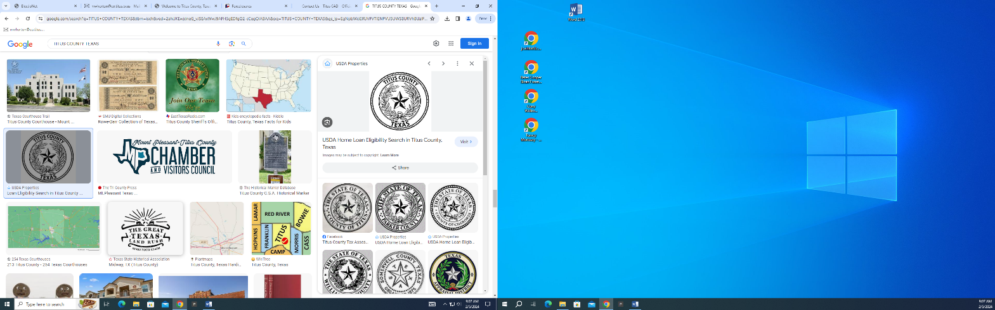

**Titus County Voter Administration**

**110 South Madison**

**Mt. Pleasant, Texas 75455**

**903-575-0902**

**Date: __________________, 20 _____ ___**

**Poll Worker Application for Elections in Titus County, Texas**

PLEASE PRINT

**Name: ______________________________________________________________**

**Address: ____________________________________________________________**

**Cell Phone: __________________________________________________________**

**Work Phone: _________________________________________________________**

**Email Address: _______________________________________________________**

**Voting Precinct: ______________________________________________________**

**Party Affiliation: ______________________________________________________**

**Would you be willing to work outside your precinct? Yes No**

**Do you have elections experience? Yes No**

**If yes, in what capacity? Judge Alternate Judge Clerk or Other ____________**

**Language Fluency: _______________________________________________**

**Relevant Physical Handicaps: __________________________________________**

**___________________________________________________________________**

**Potential Legal Conflicts: ________________________________________________**

**____________________________________________________________________**

**Additional Comments: ___________________________________________________**

**______________________________________________________________________**